**T.J.S. ENGINEERING COLLEGE**

**NAAN MUDHALVAN**

**PROJECT REPORT**

**ON**

**DOCTOR APPOINTMENT SYSTEM**

**IN PARTIAL FULFILLMENT OF REQUIREMENT**

**DEPARTMENT OF COMPUTER SCIENCE**

**BATCH 2021 – 2025**

**TEAM MEMBERS:**

1. **HARTHI KJ**
2. **KAVYA T**
3. **YUGANDHAR**
4. **CHENNAVARM DHANUSH**

**SUBMITTED TO**

**DEPARTMENT OF COMPUTER SCIENCE ENGINEERING**

**T.J.S. ENGINEERING COLLEGE**

### **Abstract:**

The **Doctor-Appointment-System** is a web-based application designed to streamline doctor-patient interaction through an efficient and user-friendly platform. Built using the **MERN stack** (MongoDB, Express.js, React.js, Node.js), the system enables patients to easily search for doctors, book, reschedule, or cancel appointments, while doctors can manage their schedules and patient information effectively. The platform also supports user authentication and role-based access control to ensure security and privacy.

The system is designed to cater to the needs of both patients and healthcare providers, offering a seamless interface for managing appointments and profile information. The project emphasizes scalability, performance, and security, incorporating technologies like JWT for authentication and bcrypt for password encryption. It also features a responsive and mobile-friendly design to ensure accessibility across all devices.

This report explores the system's **functional and non-functional requirements**, **system architecture**, **database design**, and **API design**, along with detailed steps on **implementation** and **deployment**. Additionally, it outlines the security features integrated into the application, such as **JWT authentication** and **role-based access control**. Furthermore, the report discusses **testing methodologies** including unit and integration tests, and explores **challenges** faced during development, along with their solutions. The final section looks at **future enhancements** and the potential of expanding the system's features for wider use in healthcare settings.

The Doctor-Appointment-System offers a robust solution for improving the efficiency of appointment management, contributing to better healthcare service delivery and an enhanced user experience for both patients and doctors.

### **1. Introduction:**

* **Project Overview**:

The Doctor-Appointment-System is a comprehensive web application aimed at simplifying the appointment booking process for patients and doctors. This system provides a platform for patients to search for doctors based on various criteria, such as specialty and location, and book appointments. Additionally, it allows doctors to manage their schedules, view patient appointments, and update the status of each appointment.

* **Purpose and Motivation**:

Given the increasing demand for healthcare services, traditional methods of appointment booking can lead to long wait times and scheduling inefficiencies. This project is motivated by the need for a streamlined, digital solution that enhances accessibility and management efficiency for both patients and healthcare providers.

* **Objectives**:

Key goals include creating a user-friendly interface for booking appointments, secure access for patients and doctors, and tools for healthcare providers to manage their schedules. Emphasis is placed on scalability, usability, and security.

* **Target Audience**:

The primary users are patients seeking medical appointments, doctors managing schedules, and administrative staff who may oversee system operations.

### **2. Project Requirements:**

* **Functional Requirements**:
  + *Patients*:

Register/login, manage personal profiles, search for doctors by specialty and location, book and cancel appointments, view appointment history.

* + *Doctors*:

Register, update personal profiles, manage schedules, view patient information, confirm or cancel appointments.

* + *Admin:*

Oversee user management, appointment verifications, system monitoring.

* **Non-Functional Requirements**:
  + *Performance*:

Handle high user traffic and execute queries efficiently.

* + *Reliability*:

Ensure system availability and minimize downtime.

* + *Security*:

Implement JWT for authentication, encrypt passwords, and follow secure database practices.

* + *Scalability*:

Design for future expansion of user base and features.

* + *Responsiveness*:

Provide a UI that adapts smoothly across different devices and screen sizes.

### **3. System Architecture:**

The system architecture of the **Doctor Appointment System** is designed to ensure smooth interaction between the frontend, backend, and the database. The architecture follows a **client-server** model, using the **MERN stack (MongoDB, Express.js, React.js, Node.js)**. Below, I will elaborate on the architecture and include details on the various components involved.

#### **Architecture Overview:**

The architecture can be broken down into three major components:

1. **Frontend (Client-side)**: React.js
2. **Backend (Server-side)**: Node.js with Express.js
3. **Database**: MongoDB

These components work together to facilitate communication between the user and the system, making it easy to book appointments, manage schedules, and ensure security.

#### **1. Frontend (React.js):**

* **Role**:

The frontend handles the user interface and ensures smooth communication with the backend via API calls.

* **Components**:
  + **React Components**:

These include UI elements such as buttons, forms, and cards used by both patients and doctors. Components are reusable and state driven.

* + **State Management**:

The application uses **React state management** for storing the user's session, appointment data, and dynamic UI updates.

* + **API Integration**:

Axios or the Fetch API is used to make asynchronous requests to the backend for data retrieval, such as fetching doctors, booking appointments, and updating user profiles.

* + **Routing**:

**React Router** manages navigation within the app, allowing users to seamlessly move between pages like the homepage, doctor search, booking page, and user dashboard.

* **User Interaction**:
  + **Patient Side**:

Patients can log in, search for doctors based on specialty and location, book appointments, and view their booking history.

* + **Doctor Side**:

Doctors can manage their schedules, accept or reject appointments, and see their patient list.

* + **Admin Panel**:

If applicable, administrators can oversee the entire system and view all appointments.

#### **2. Backend (Node.js + Express.js):**

* **Role**:

The backend provides the core logic of the application, handles requests from the frontend, and interacts with the database.

* **Components**:
  + **Node.js**:

A JavaScript runtime that allows the server to run JavaScript code. Node.js is non-blocking, making it efficient for handling multiple requests simultaneously.

* + **Express.js**:

A web framework for Node.js that simplifies the development of APIs. It provides routing, middleware, and error handling. Express.js enables the system to expose RESTful endpoints to handle user registration, login, appointment bookings, and more.

* **Key Features**:
  + **Authentication**:

The backend handles user authentication using **JWT (JSON Web Tokens)**. Once a user logs in, the server generates a JWT, which is used to authenticate future requests.

* + **Appointment Management**:

The backend handles all appointment data — creating, updating, deleting, and viewing appointments.

* + **Role-based Access Control**:

The backend restricts access to certain API endpoints based on the user's role (e.g., patient, doctor, admin).

* + **Error Handling**:

Error middleware catches and returns appropriate responses when something goes wrong (e.g., invalid input or unauthorized access).

#### **3. Database (MongoDB):**

* **Role**:

MongoDB stores and manages application data, including user information (patients and doctors), appointments, and booking details.

* **Features**:
  + **NoSQL**:

MongoDB is a NoSQL database, making it highly flexible and scalable. It uses collections and documents instead of traditional rows and tables.

* + **Collections**:

The database consists of several collections like users, appointments, doctors, etc.

* + **Mongoose ORM**:

MongoDB's native query language is a bit low-level, so **Mongoose** is used as an Object Data Modeling (ODM) library to interact with MongoDB. It provides an abstract layer and simplifies CRUD operations.

* **Sample Data**:

**User Collection**:

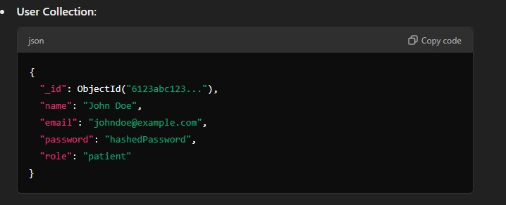

**Appointment Collection**:

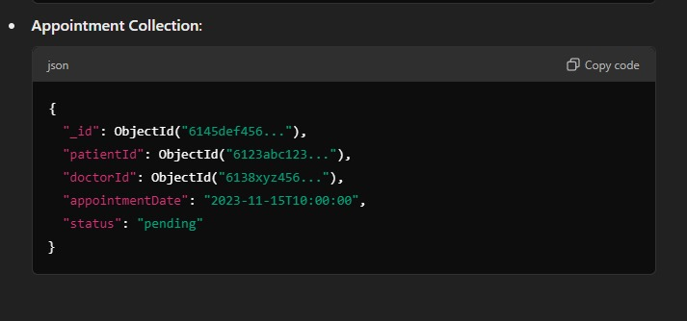

### **System Architecture Diagram:**

* The following diagram shows the flow and interaction between the components in the Doctor Appointment System:
  + **Frontend (React.js)**:

The user interacts with the frontend (browser or mobile app).

* + **Backend (Node.js + Express.js)**:

The frontend communicates with the backend via RESTful API requests.

* + **Database (MongoDB)**:

The backend interacts with the database to store and retrieve data.

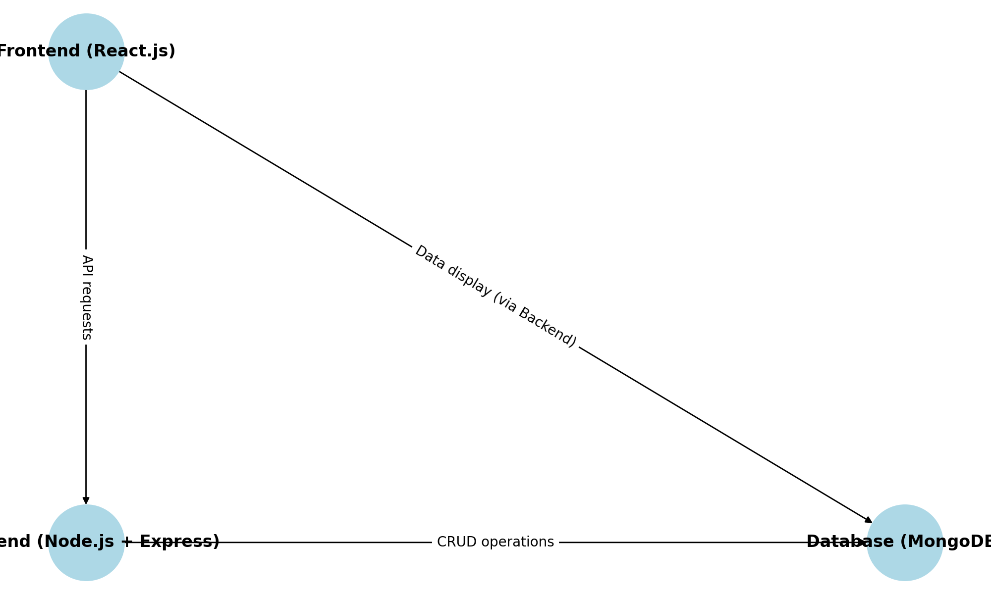

### **Explanation of the Diagram:**

* **Frontend (React.js)**:
  + The user interacts with the UI, where data is displayed and updated dynamically.
  + Patient and doctor actions trigger API requests to the backend (e.g., booking an appointment, viewing a profile).
  + The frontend uses HTTP (GET, POST, PUT, DELETE) methods to communicate with the backend.
* **Backend (Node.js + Express)**:
  + It listens for requests from the front-end and processes them using routes defined in Express.js.
  + Authentication is handled using JWT tokens, ensuring secure access to protected routes.
  + The backend communicates with MongoDB to fetch or update data.
* **Database (MongoDB)**:
  + Stores user information, appointments, doctor schedules, etc.
  + The backend performs CRUD operations on this data using MongoDB and Mongoose ORM.
  + The database is hosted on a cloud solution like **MongoDB Atlas** for scalability.

### **Key Architectural Components Breakdown:**

* + **Client-Side (React.js)**:
    - **React Router** for navigation.
    - **Axios** for making API calls to the backend.
    - **Redux** (or Context API) for managing the state of the application scales.
    - **Material UI** or **Bootstrap** for UI components.
  + **Server-Side (Node.js + Express.js)**:
    - **Express.js** handles routing, middleware, and API request handling.
    - **JWT Authentication** ensures that only authorized users can access protected routes.
    - **Mongoose ORM** makes database interaction easy by providing schema definitions and querying functions.
  + **Database (MongoDB)**:
    - A NoSQL database designed to handle large volumes of data efficiently.
    - **Collections** like users, appointments, and doctors store application data.
    - **Cloud hosting (MongoDB Atlas)** provides automatic backups and scaling.

### **4. Database Design:**

* **ER Diagram**:
  + An ER diagram would show entities such as User, Doctor, and Appointment, with relationships among them, providing a visual reference of database structure.

#### **Entities and Attributes:**

1. **User**:
   1. **_id** (PK), **name**, **email**, **password**, **role** (patient/doctor).
2. **Doctor**:
   1. **_id** (PK), **name**, **specialty**, **available_times**, **location**.
3. **Booking**:
   1. **_id** (PK), **doctorId** (FK), **patientId** (FK), **date**, **status**.

#### **Relationships:**

* **User to Appointment**:

One patient can have many appointments (One-to- Many).

* **Doctor to Appointment**:

One doctor can have many appointments (One-to- Many).

* **User to Doctor**:

Many patients can book appointments with many doctors (Many-to-Many via Appointment).

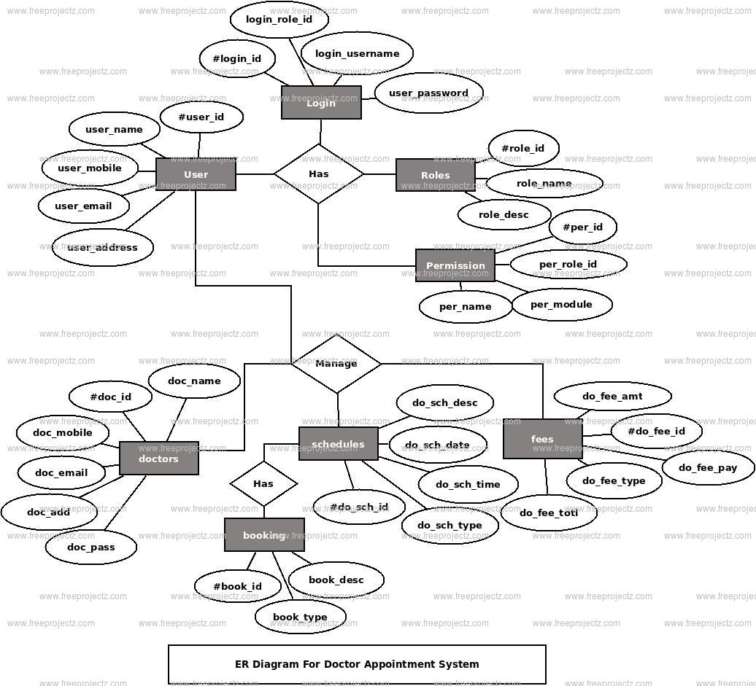

* **Collections**:
  + *Users*:

Stores basic user details, including role-based data (patient or doctor), facilitating access control.

* + *Appointments*:

Manages appointment information, including patient, doctor, date, and status fields.

* **Data Flow**:
  + When a patient books an appointment, a document is created in the Appointment collection, which links to both the patient and doctor through their IDs.
* **Sample Documents**:

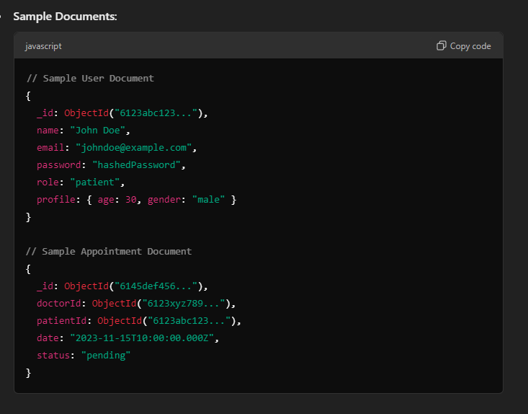

### **5. System Components:**

* **Frontend (React.js)**:

The frontend is developed using React.js, creating a component-based structure that enables modular, reusable elements. The main pages include:

* + - **Login and Registration**:

Allows users to create accounts or access existing ones.

* + - **Dashboard**:

The main interface where users can view or manage appointments.

* + - **Profile Management**:

Provides an interface for updating personal details and preferences.

* + - **Appointment Booking**:

Patients can search by doctor, specialty, and availability to book an appointment. This component includes a calendar interface for date selection.

* + - **State Management**:

Redux is employed for managing the global state, including user authentication, profile data, and appointment status. Redux simplifies data sharing across components and maintains a central store of application state.

* + - **HTTP Requests with Axios**:

Axios is used to communicate with the Express backend, sending data like login credentials, appointment requests, and profile updates.

* + - **UI Libraries**:

Ant Design and Bootstrap are used to provide pre- designed components like buttons, forms, and grids, ensuring a responsive and visually consistent user interface.

* **Backend (Express.js & Node.js)**:

The backend, structured using Express.js, manages the API routes, request handling, and data processing logic. Major routes include:

* + - **User Routes**:

Handles registration, login, and profile management.

* + - **Appointment Routes**:

Manages appointment creation, updates, and cancellations.

* + - **Doctor Routes**:

Allows doctors to view, confirm, or cancel appointments.

* + - **Authentication and Authorization**:

JWT-based authentication secures access, while role-based checks in middleware restrict access to specific features based on user roles.

* + - **Mongoose ORM**:

Mongoose is used to interact with MongoDB, enabling schema-based data models for validation and query building.

* + - **Error Handling and Logging**:

Errors are caught and logged using custom error handlers, ensuring issues are quickly identified and resolved.

* **Database (MongoDB)**:

MongoDB, a NoSQL database, is used to store data in flexible JSON-like documents. Collections include:

* Users
* Appointments
* Data Storage and Retrieval
* **Users**:

Stores patient and doctor information.

* **Appointments**:

Records booking details and links to user profiles.

* **Data Storage and Retrieval**:

Queries allow for efficient storage and retrieval of user profiles and appointments, with indexing applied on frequently queried fields for optimized performance.

### **6. Security Features:**

* **JWT Authentication**:
  + JWT (JSON Web Token) is used for secure user authentication. A token is generated upon successful login, containing encoded user information and a signature. The token is stored on the client side (typically in local storage or a cookie) and sent with each request for backend verification.
* ***Code for Token Generation*:**

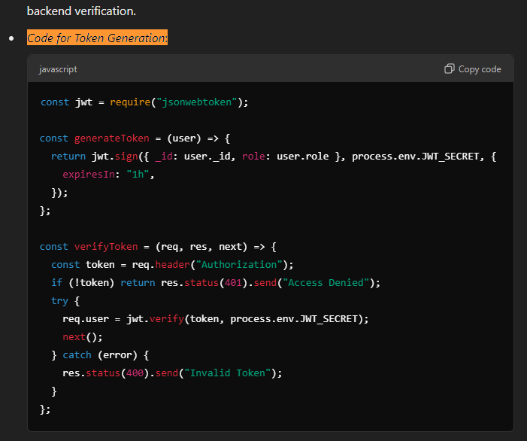

* **Role-Based Access Control (RBAC)**:

Role-based access control is implemented by checking the user’s role within the JWT. Different permissions are granted for patients and doctors, preventing unauthorized access. Middleware functions enforce these role checks before route access.

* **Password Encryption**:

Passwords are hashed with bcrypt before storage in MongoDB, adding a layer of security. Even in the event of a database breach, passwords remain protected as bcrypt hashes cannot be easily reversed.

* **Secure Database Access**:

MongoDB access is secured with environment variables for connection strings and limited user privileges. Access to sensitive fields, like JWT tokens, is handled over HTTPS to prevent exposure.

### **7. User Interface Design:**

* **Wireframes**:

Wireframes for key pages (Login, Profile, Dashboard, Booking) were created during the design phase to plan layout and functionality. Wireframes ensure that the flow is intuitive, with essential elements like buttons and navigation links strategically placed.

* **Responsive Design**:
  + A mobile-first approach was adopted, ensuring that the interface works seamlessly on smartphones, tablets, and desktops. The use of media queries and Bootstrap's responsive grid system ensures that the layout adjusts based on screen size.
* **Example CSS for Responsiveness:**

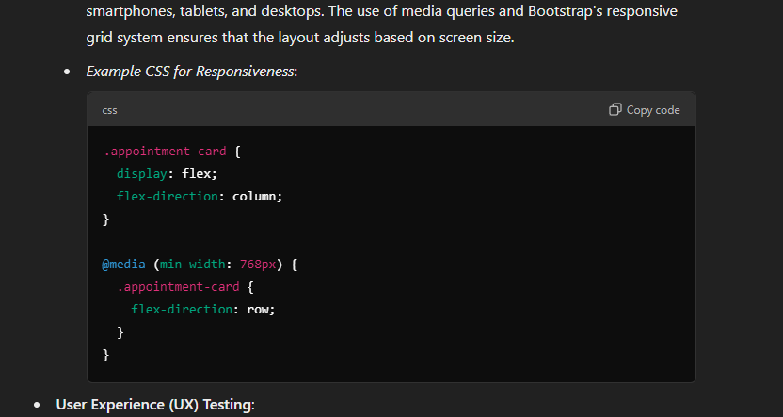

* **User Experience (UX) Testing**:
  + UX testing was conducted to assess usability, ease of navigation, and overall flow. Testers simulated various scenarios, such as booking appointments, updating profiles, and canceling appointments, to identify usability improvements.
  + **Accessibility Considerations**:

Elements like button labels, form fields, and headings are screen-reader friendly, enhancing accessibility for visually impaired users.

* **UI Libraries**:

Ant Design and Bootstrap enhance the user interface with a polished look. Components such as modal windows, calendar inputs, and interactive forms are provided by these libraries, streamlining design and ensuring a consistent appearance.

### **8. API Design:**

* **RESTful API Endpoints**:
  + The backend exposes RESTful APIs to handle user authentication, appointment management, and doctor scheduling. Each API is structured to follow the HTTP method conventions: GET (retrieve), POST (create), PUT (update), DELETE (remove).
  + **Sample API for Appointment Booking**:
    - *POST /appointments*: Allows a patient to book an appointment.
    - *GET /appointments/*: Fetches the details of a specific appointment.
    - *PUT /appointments/*: Updates the status of an appointment.
    - *DELETE /appointments/*: Cancels the appointment.
* **Diagram:**

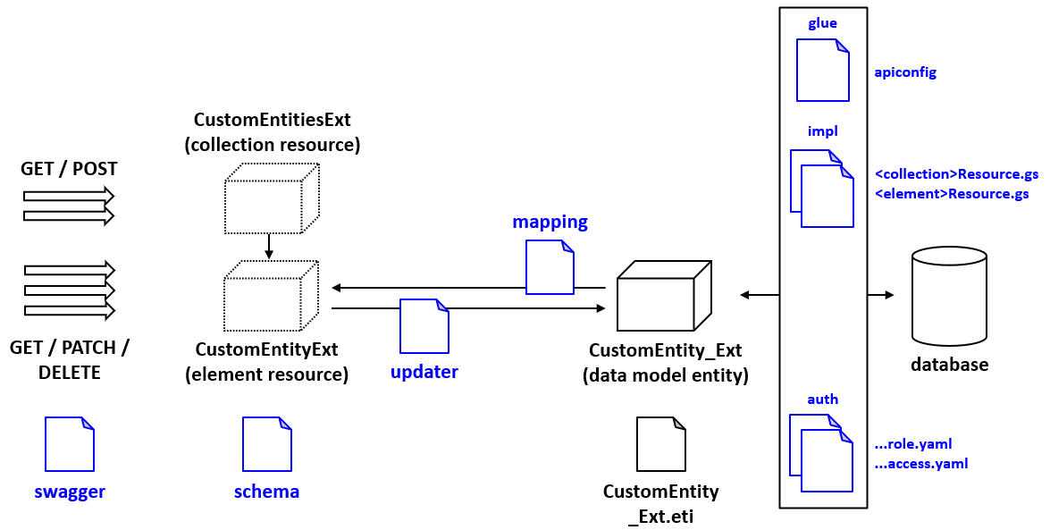

* **API Authentication**:

Each API request must include a valid JWT token in the authorization header to access protected resources.

* **API Documentation**:

API documentation is generated using tools like Swagger, enabling easy understanding and usage by frontend developers or external systems that may interact with the backend.

* **Sample Endpoint Definitions**:

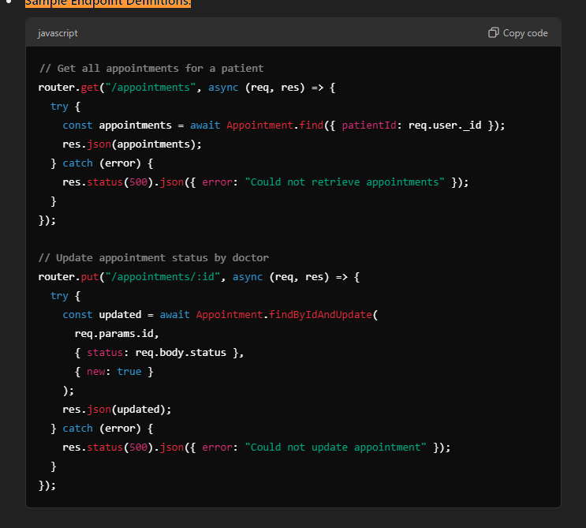

### **9. Implementation:**

The implementation phase involved setting up the development environment, coding the frontend and backend features, and integrating the database. The project was divided into the following steps:

* **Frontend Implementation**:

Created UI components using React.js and connected them with the backend via API requests.

* **Backend Implementation**:

Developed Express.js routes for managing user authentication, appointments, and schedules.

* **Database Integration**:

Configured MongoDB collections for users and appointments, using Mongoose ORM to interact with the database.

* **Testing**:

Implemented unit tests for individual components and integration tests for the whole system.

* **Server Configuration**:

Environment variables store database URIs and other sensitive data for secure and scalable deployment.

* **Sample App Configuration (app.js)**:

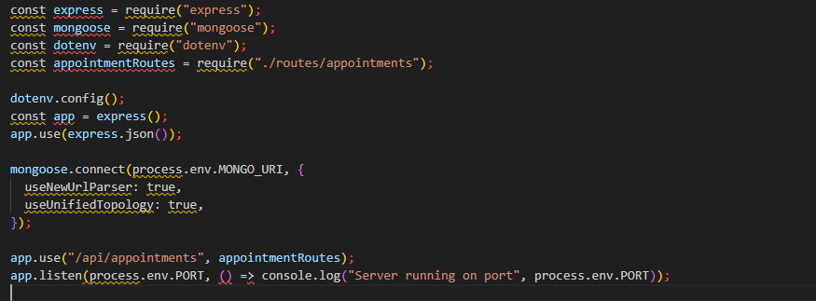

### **10. Testing:**

* **Types of Testing**:
  + *Unit Testing*:

Unit testing focuses on testing individual components or units of code to ensure they function correctly in isolation. Each unit (such as a function or a module) is tested by providing specific inputs and checking if the output is correct. This type of testing helps detect bugs early and ensures that every small part of the system is working as expected.

#### **Example:**

For the BookAppointment component in React, unit tests can be written to check if the component renders correctly, handles events like clicking buttons, and manages state updates.

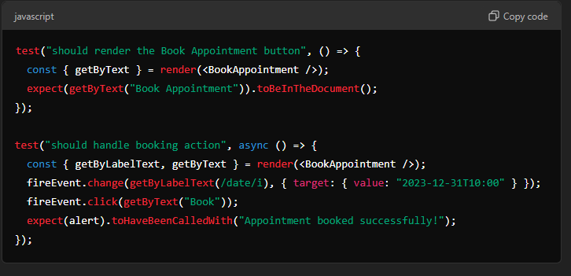

* + *Integration Testing*:

Integration testing ensures that different modules or components of the application work together as expected. While unit tests focus on individual components, integration tests validate the interactions between them. For example, when a user books an appointment, integration testing would check if the interaction between the frontend (React), backend (Express), and database (MongoDB) functions correctly.

#### **Example:**

In the case of booking an appointment, an integration test can ensure that when an appointment is created, the data flows from the frontend to the backend and is stored correctly in the database.

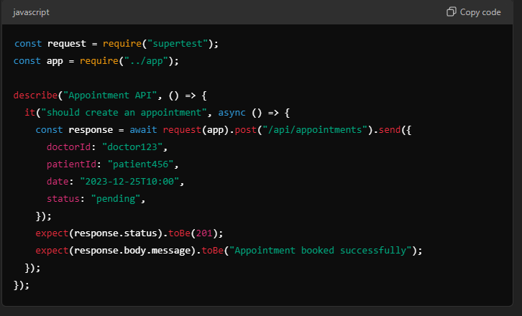

* + *End-to-End Testing*:

End-to-end testing is the process of testing the complete workflow of the application, from start to finish, to ensure that all components and interactions work as expected in a real-world scenario. This involves simulating user actions such as logging in, searching for a doctor, booking an appointment, and confirming the appointment.

#### **Example:**

Testing the entire flow of booking an appointment, including user registration, doctor search, selecting a time slot, booking, and viewing the confirmation.

* **Testing Tools**:

List of tools (e.g., Jest for React, Mocha for backend testing, Postman for API testing).

* **Unit Tests for Components**:
  + Tests using Jest for front-end components.

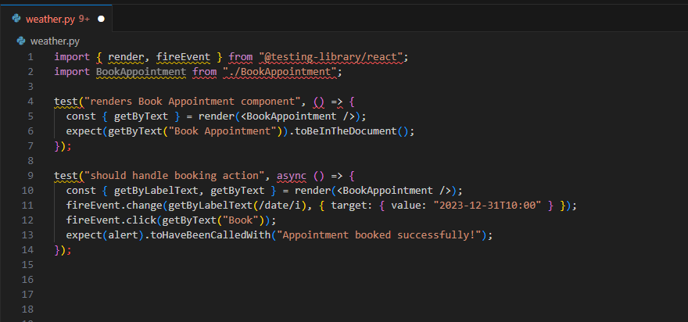

* **Integration Tests**:
  + Test routes in Express using supertest.

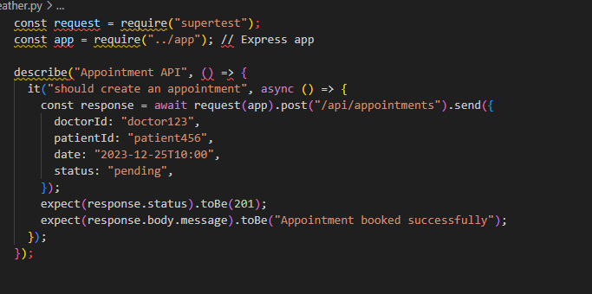

**Test Cases for the Doctor Appointment System**:

|  |  |  |  |
| --- | --- | --- | --- |
| **Test Case ID** | **Test Description** | **Expected Result** | **Status** |
| TC01 | User Registration | User successfully registers with valid input. | Pass/Fail |
| TC02 | User Login | User logs in with correct credentials and is redirected to the dashboard. | Pass/Fail |
| TC03 | User Login with Invalid Credentials | User sees an error message for invalid credentials. | Pass/Fail |
| TC04 | Patient Books Appointment | Appointment is successfully booked and appears in the patient's dashboard. | Pass/Fail |
| TC05 | Doctor Confirms Appointment | Doctor can confirm the appointment from their dashboard. | Pass/Fail |
| TC06 | Patient Cancels Appointment | Appointment is removed from both patient and doctor's dashboards. | Pass/Fail |
| TC07 | Doctor Updates Appointment Status | The doctor can change the status of an appointment (e.g., completed, pending). | Pass/Fail |
| TC08 | Admin Views All Appointments | Admin can view a list of all appointments across users. | Pass/Fail |
| TC09 | User Profile Update | Users can update personal details, and changes are reflected immediately. | Pass/Fail |
| TC10 | JWT Authentication (Valid Token) | The system grants access to protected routes when the token is valid. | Pass/Fail |
| TC11 | JWT Authentication (Invalid Token) | System returns an error for invalid or expired tokens. | Pass/Fail |
| TC12 | Password Hashing and Salting | Password is stored as a hashed value, not plain text. | Pass/Fail |
| TC13 | Database Interaction | Data is properly inserted and queried from MongoDB (appointments, users). | Pass/Fail |
| TC14 | Frontend Responsiveness | UI elements adapt to different screen sizes (desktop, tablet, mobile). | Pass/Fail |
| TC15 | End-to-End Test (Booking, Confirmation) | Full flow: Patient books an appointment, doctor confirms it, and status updates. | Pass/Fail |

### **11. Deployment:**

The deployment process involves preparing the application for production and ensuring that it runs efficiently in a lively environment. It also includes making the system publicly accessible and ensuring its stability across devices and users.

* **Deployment Steps**:

1. **Prepare the Application for Deployment**:

Run npm, run build for React, ensuring the build is optimized for production.

1. **Choose Hosting Platform**:

Frontend deployment on platforms like **Netlify** or **Vercel**, and backend on platforms like **Heroku** or **AWS**.

1. **Database Hosting**:

Use **MongoDB Atlas** or **AWS** for cloud-based MongoDB hosting.

1. **CI/CD Configuration**:

Use GitHub Actions, CircleCI, or GitLab CI for automating builds and deployments.

1. **Deploy Frontend**:

Upload build files to **Netlify**, **Vercel**, or **AWS S3**.

1. **Deploy Backend**:

Use **Heroku** or **AWS Elastic Beanstalk** for backend deployment.

1. **Environment Variables**:

Set production-specific variables for secure configurations.

1. **SSL Configuration**:

Set up SSL for secure HTTPS access.

1. **Monitoring and Scaling**:

Use **AWS CloudWatch** or similar tools for application monitoring and scaling resources as needed.

1. **Configure Domain**:

Set DNS for custom domain configuration.

1. **Final Testing**:

Test the live application to ensure all functionalities work as intended.

### **12. Challenges and Solutions:**

* **Data Consistency**:

Managing asynchronous data flows in MongoDB to ensure consistent data during peak usage.

* + *Solution*:

Implemented transactions using MongoDB’s session to maintain atomic operations, especially in booking and updating appointments.

* **Role-Based Access Control (RBAC)**:

Ensuring that users access only permitted functionalities based on their role.

* + *Solution*:

JWT includes a role claim which is verified in middleware before accessing restricted routes.

* **Handling Multiple Time Zones**:

Converting and storing times to UTC to manage bookings across different time zones.

* + *Solution*:

Leveraged Moment.js for time conversions and set all time inputs and outputs to UTC for consistency.

* **Responsive UI Across Devices**:

Ensuring the app is fully functional on various devices.

* + *Solution*:

Used Bootstrap and CSS media queries to create a responsive and consistent design across mobile, tablet, and desktop views.

### **13. Future Enhancements:**

* **Real-Time Notifications**:

Integrate notifications for appointment reminders, cancellations, or confirmations.

* **Video Consultation Feature**:

Add an option for virtual consultations to enable remote healthcare.

* **Feedback and Ratings System**:

Allow patients to rate doctors and leave feedback to enhance service quality.

* **Advanced Search Filters**:

Implement filtering options by insurance provider, language, and proximity.

* **Multi-User Role Support**:

Add additional roles, such as administrative staff, to manage clinic-wide operations.

### **14. Conclusion:**

* **Project Summary**:

The Doctor-Appointment-System effectively facilitates doctor-patient interactions by providing a platform that allows patients to find and book appointments easily and doctors to manage their schedules. The application successfully implements core features such as secure login, role-based access, and responsive UI.

* **Key Achievements:**
* The system's architecture, designed with a modular approach, ensures flexibility, scalability, and maintainability. The separation of concerns between frontend, backend, and database layers ensures clear boundaries of functionality, making it easier to manage and extend the system in the future.
* The user interface has been designed with simplicity and ease of use in mind. By leveraging modern web technologies like React, we ensured an interactive and responsive experience, making it easy for users to book appointments, search for doctors, and view their schedules. The system also allows for easy management of user data and appointments by healthcare providers.
* The database schema was carefully designed to handle relationships between patients, doctors, and appointments. The use of normalization techniques ensures data integrity and reduces redundancy, while foreign key constraints maintain referential integrity.
* Robust security features, such as encrypted passwords, JWT authentication, and data validation mechanisms, were implemented to safeguard user data and ensure the privacy and security of sensitive information. The system also includes user roles (admin, doctor, patient) with appropriate access control to ensure that each user can only access relevant data and perform authorized actions.
* A comprehensive testing approach was adopted, including unit testing, integration testing, end-to-end (E2E) testing, API testing, and performance testing. The use of tools like Jest, React Testing Library, Cypress, Postman, and Apache JMeter ensured the quality and reliability of the application. These tests helped to identify and fix issues early in the development cycle, reducing bugs and improving the system's overall performance.
* **Reflection and Final Thoughts**:
* The Doctor Appointment Management System project has provided a comprehensive learning experience, allowing me to apply theoretical knowledge in a real-world scenario while addressing various technical, operational, and design challenges. The process of developing this system, particularly using the MERN stack, deepened my understanding of full-stack web development, system architecture, and integration of front-end and back-end components.
* One of the most rewarding aspects of this project was gaining insight into the importance of user-centered design. Understanding the needs of patients and doctors helped in creating an intuitive interface that simplifies appointment booking, profile management, and schedule handling. A seamless user experience was critical to ensure that both patients and healthcare professionals could easily interact with the system, and achieving that required a thoughtful approach to UI/UX design, particularly ensuring accessibility and mobile responsiveness.
* The project also emphasized the significance of security and data privacy. Implementing JWT-based authentication, password encryption with bcrypt, and role-based access control (RBAC) were vital in ensuring that sensitive patient and doctor information remains protected. Understanding the legal and ethical considerations in handling healthcare data further reinforced the importance of creating secure systems.
* In the final analysis, the project not only allowed me to develop a functional and scalable appointment system but also reinforced my technical abilities and improved my understanding of real-world software development practices. The project has also inspired further ideas for enhancements, such as introducing video consultations and real-time notifications. Overall, this experience has been incredibly enriching, and I look forward to improving this system further, making it more robust, user-friendly, and valuable to healthcare providers and patients alike.

### **15. Reference:**

* **MongoDB (Database):** **https://docs.mongodb.com/**
* **Express.js (Backend Framework):** **https://expressjs.com/**
* **React.js (Frontend Framework):** **https://reactrouter.com/**
* **Node.js (Runtime Environment):** **https://www.youtube.com/watch?v=TlB_eWDSMt4**
* **JSON Web Tokens (JWT) for Authentication:** **https://jwt.io/**
* **Git & Version Control:** **https://git-scm.com/doc**
* **Deployment (e.g., Heroku or AWS):** **https://docs.aws.amazon.com/ec2/index.html**
* **Testing Frameworks:** **https://mochajs.org/**
* **CSS Frameworks for Styling (Optional, e.g., Bootstrap):** **https://mui.com/**